Bundanoon - Morton National Park
3 Entry Points – Gullies Rd, Riverview Rd & Badgerys Spur Access

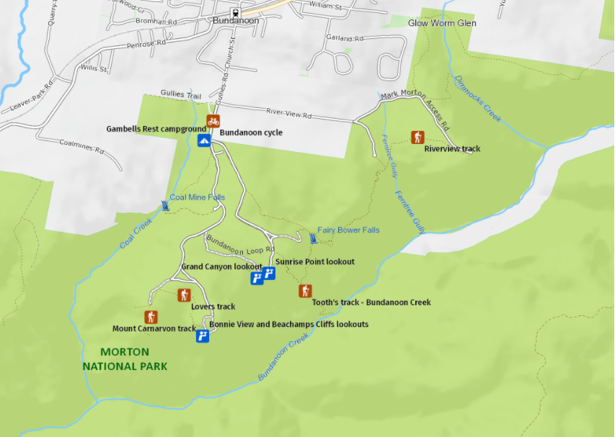
At a glance

Numerous Trail Options

Grade:
Easy to Advanced

Time:
30 minutes – 4 hours

Distance:
1km – 7km return

Facilities:
Toilets
Picnic tables
BBQ facilities
Drinking water
Showers
Car Parking

Conditions:
$8 car parking fee
Dogs not permitted
No smoking

A wide range of activities for the whole family
Bundanoon is the northern gateway to Morton National Park. Follow the well-marked bushwalking trails in one of NSW's largest national parks, admiring waterfalls that plunge into valleys below.
This enormous park really does have something for everyone; whether you’re an experienced bushwalker looking for remote wilderness hiking, a novice mountain biker looking for an easy ride or a keen photographer looking for some scenic waterfalls to capture.

You’ll find imposing gorges dissecting the landscape alongside pockets of rainforests that are full of wildlife. There are a number of well-equipped picnic areas and numerous informal spots where you can stop for a break to enjoy the views.

Camping
If you’d like to go camping, head to Gambells Rest campground in the Bundanoon precinct of the park.

Walks
There are numerous walking tracks through the Bundanoon Section of the Morton National Park. The walks abound in native flora and vary in length and difficulty.

Erith Coal Mine Track

1 hr return
- Start: Gambells Rest
- Grade: Steep
This short, steep walk through woodland, heath and rainforest leads to a mine that was open from the 1860s to 1915.

Echo Point and Lovers Walk

1 hr loop
- Start: Echo Point picnic area
- Grade: easy
Take the Lovers Walk turn off on the right and follow the track to Bonnie View for a spectacular panorama.

Mount Carnarvon Track

30 mins return
- Start: Echo Point picnic area
- Grade: easy, some steps
A short, pretty walk through bushland to the escarpment returning the same way.

Fern Glen Track

15 mins return
- Start: Grand Canyon Picnic Area
- Grade: easy
This short walk leads to a moist, rocky haven – home to some gigantic king ferns and other moisture-loving plants.

Fairy Bower Scenic Circuit

1 hr loop
- Start: Gambells Rest car park
- Grade: steep
Walk through the back of the camping area along the road to the Fairy Bower sign on the left’

Tooths Lookout/Fairy Bower Falls Walk

1.5 hr return
- Start: Tooths Lookout car park
- Grade: very steep
Follow Bundanoon Creek Track down a very steep incline near the lookout.

Bundanoon Creek Trail
- 2 hr return
- Start: Tooths Lookout car park
- Grade: very steep
Follow the track down a very steep incline (past the Fairy Bower Falls turn-off) to Bundanoon Creek

Amphitheatre Walk

3 hr loop
- Start: Gambells Rest car park
- Grade: medium (steps)
Take the road outside the park (Gullies Road) to Riverview Road and turn right.
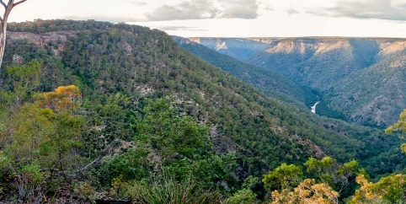

Riverview Walk

40 min rtn – Riverview Lookout

1.5 hr return to Glow Worm Glen
- Start: Amphitheatre car park
- Grade: medium
A pretty walk across Fern Tree Gully through dry eucalypt forest to Riverview Lookout.

Dimmocks Creek Walk

30 min rtn
- Start: Dimmocks Creek car park
- Grade: easy
Short walk to Dimmocks Creek (return the same way).
Things to remember
- For further info about walking tracks please contact National Parks & Wildlife at Fitzroy Falls on 02 4887 7270
- Stay on the track – help protect bushland by not damaging any flora or fauna
- Observe fire bans
- No firearms or hunting equipment to be carried
- Take your rubbish home
- Use sunscreen
- Water is not provided
- There are no toilets
- Always tell someone where you are bushwalking.
- Download the Emergency Plus App before bushwalking

